UNITED STATES
SECURITIES AND EXCHANGE COMMISSION
Washington, D.C. 20549

SCHEDULE 14A

Proxy Statement Pursuant to Section 14(a) of the
Securities Exchange Act of 1934 (Amendment No. )

☒ | Filed by the Registrant |  | ☐ | Filed by a party other than the Registrant

CHECK THE APPROPRIATE BOX:
☐ | Preliminary Proxy Statement
☐ | Confidential, for Use of the Commission Only (as permitted by Rule 14a-6(e)(2))
☐ | Definitive Proxy Statement
☒ | Definitive Additional Materials
☐ | Soliciting Material under § 240.14a-12



Assembly Biosciences, Inc.
(Name of Registrant as Specified In Its Charter)
(Name of Person(s) Filing Proxy Statement, if other than the Registrant)

PAYMENT OF FILING FEE (CHECK ALL BOXES THAT APPLY):
☒ | No fee required
☐ | Fee paid previously with preliminary materials
☐ | Fee computed on table in exhibit required by Item 25(b) per Exchange Act Rules 14a-6(i)(1) and 0-11

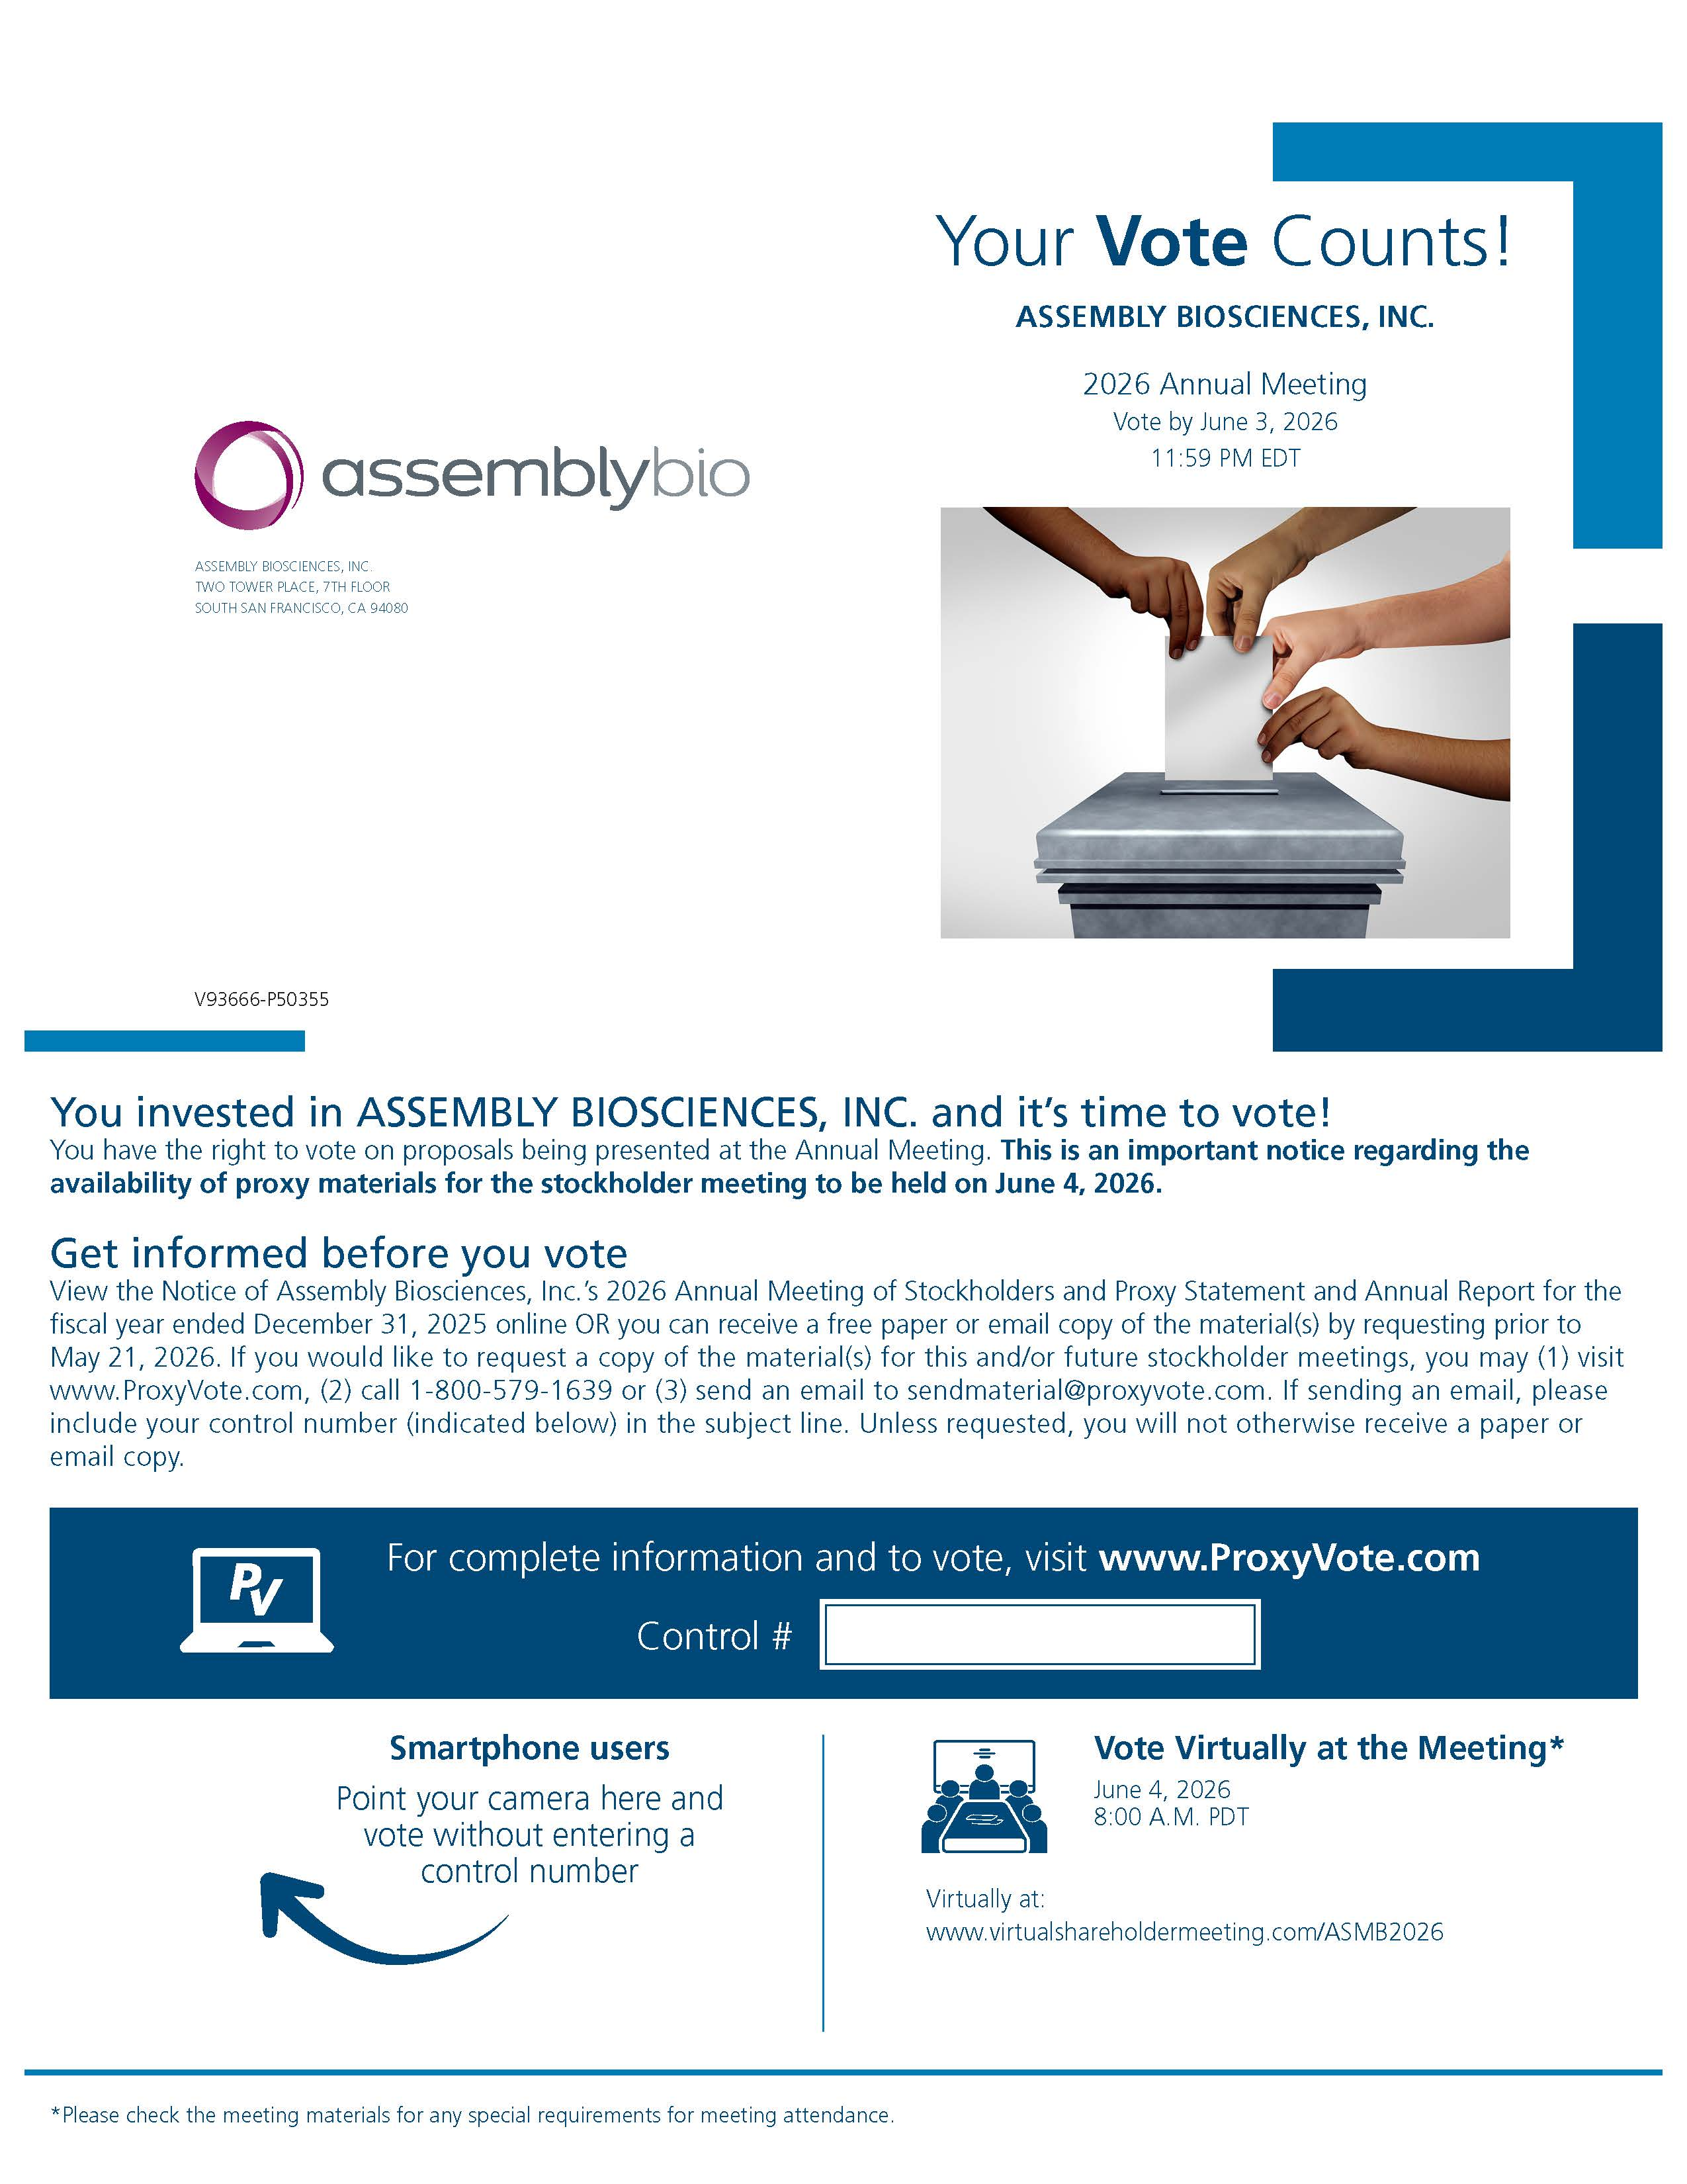
Your Vote Counts! ASSEMBLY BIOSCIENCES, INC. 2026 Annual Meeting Vote by June 3, 2026 11:59 PM EDT assemblybio ASSEMBLY BIOSCIENCES, INC. TWO TOWER PLACE, 7TH FLOOR SOUTH SAN FRANCISCO, CA 94080 You invested in ASSEMBLY BIOSCIENCES, INC. and it’s time to vote! You have the right to vote on proposals being presented at the Annual Meeting. This is an important notice regarding the availability of proxy materials for the stockholder meeting to be held on June 4, 2026. Get informed before you vote View the Notice of Assembly Biosciences, Inc.’s 2026 Annual Meeting of Stockholders and Proxy Statement and Annual Report for the fiscal year ended December 31, 2025 online OR you can receive a free paper or email copy of the material(s) by requesting prior to May 21, 2026. If you would like to request a copy of the material(s) for this and/or future stockholder meetings, you may (1) visit www.ProxyVote.com, (2) call 1-800-579-1639 or (3) send an email to sendmaterial@proxyvote.com. If sending an email, please include your control number (indicated below) in the subject line. Unless requested, you will not otherwise receive a paper or email copy. For complete information and to vote, visit www.ProxyVote.comControl # Smartphone users Point your camera here and vote without entering a control number Vote Virtually at the Meeting* June 4, 2026 8:00 A.M. PDT Virtually at: www.virtualshareholdermeeting.com/ASMB2026*Please check the meeting materials for any special requirements for meeting attendance.

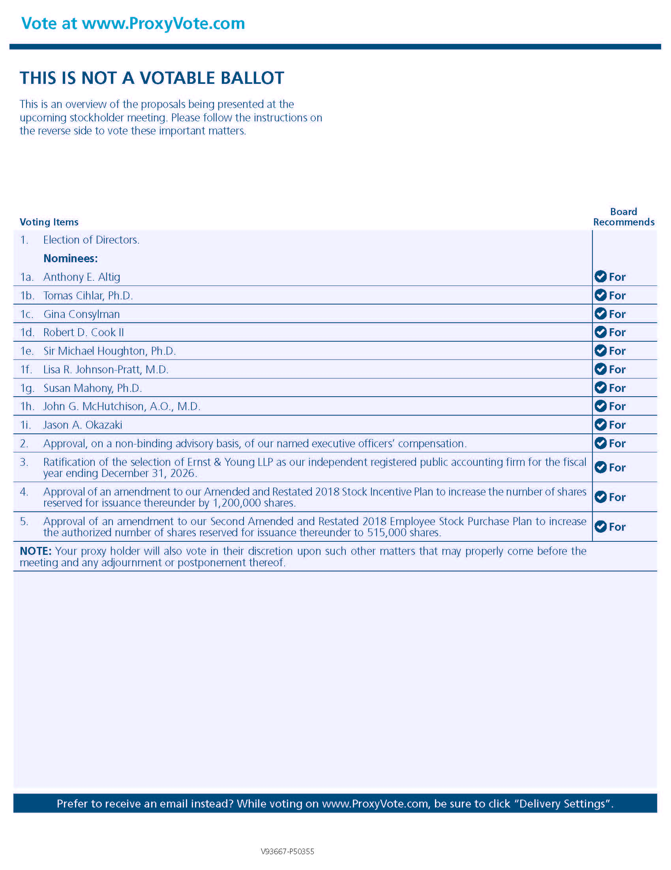
Vote at www.ProxyVote.com THIS IS NOT A VOTABLE BALLOT This is an overview of the proposals being presented at the upcoming stockholder meeting. Please follow the instructions on the reverse side to vote these important matters. Voting Items 1. Election of Directors. Nominees: 1a. Anthony E. Altig 1b. Tomas Cihlar, Ph.D. 1c. Gina Consylman 1d. Robert D. Cook II 1e. Sir Michael Houghton, Ph.D. 1f. Lisa R. Johnson-Pratt, M.D. 1g. Susan Mahony, Ph.D. 1h. John G. McHutchison, A.O., M.D. 1i. Jason A. Okazaki 2. Approval, on a non-binding advisory basis, of our named executive officers’ compensation. 3. Ratification of the selection of Ernst & Young LLP as our independent registered public accounting firm for the fiscal year ending December 31, 2026. 4. Approval of an amendment to our Amended and Restated 2018 Stock Incentive Plan to increase the number of shares reserved for issuance thereunder by 1,200,000 shares. 5. Approval of an amendment to our Second Amended and Restated 2018 Employee Stock Purchase Plan to increase the authorized number of shares reserved for issuance thereunder to 515,000 shares. NOTE: Your proxy holder will also vote in their discretion upon such other matters that may properly come before the meeting and any adjournment or postponement thereof. Board Recommends For For For For For For For For For For For For For Prefer to receive an email instead? While voting on www.ProxyVote.com, be sure to click “Delivery Settings”.

